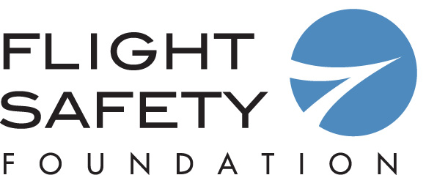

Call for Nominations
FSF Business Aviation Meritorious Service Award

This award, presented by the Foundation since 1975, is for outstanding service and contributions to business aviation safety. The award recognizes individuals whose work has enhanced safety in this segment of the industry. Recipients have included industry leaders, government officials, members of the news media and researchers whose findings were especially relevant to business aviation. The deadline for nominations is March 30, 2018.

The award will be presented at the 63rd annual Business Aviation Safety Summit (BASS 2018), May 10–11, 2018, in Chicago.

Name of Nominee:

Position/Company:

Address:

Phone/Fax/Email:

***Please attach a one-page document to support your nomination. Nominations without supporting materials may not be considered by the Award Board. ***

Nomination submitted by:

Name:

Address:

Telephone:

Fax:

Email:

Deadline: March 30, 2018
Please return to Frank Jackman at jackman@flightsafety.org
Attention: FSF – Business Aviation Meritorious Service Award
Thank you for your nomination.

